Welcome to KasiCrafts.co.za

Quick Guide

# Table of Contents

1. Purpose of the website
2. How to Register (optional)
3. How to logon (optional)
4. How to Register a Business
5. How to Add products
6. How to Add product pictures
7. How to Manage product Prices
8. Managing communication/ Messsages with potential clients
9. Products liked

1. Purpose kasicrafts.co.za

The primary purpose of this website is to create an environment where small kasi businesses can advertise their products and services. The goal is to provide our services from the product being advertised, to the selling, communication, selling/purchasing of a products or service, until the delivery of the product/service (Some functionality is still being built). With that being said, currently the following functionality is available:

1. Search for products or services
2. Option to like and have that saved. This will help remind people what they wanted earlier on
3. Communication: sending an email to the product or service provider. Registered people can send messages back and forth, but those who are not registered will have to provide their email address at the time of sending a message. That can limit a conversation to a one send and one reply, this is because when they visit the site again, we can’t confirm if its them or not.
4. All providers can create accounts for their businesses, add products and services that they provide, and advertise them.
5. Advertise Sale Items and provide specials
6. Mostly importantly highlight the businesses and opportunities in our back doors

# 2. How to Register

Why?

Registration is simple and straight forward, and it has been designed to be like so that it enables people to enjoy the following benefits without any hustle:

1. Allows you to add your business, including the products you sell with a sample pictures
2. Allows you to add contact details, which in turn enables businesses /or potential customers be able to contact you easily. This is done using the application functionality.
3. For a ordinary person, a like helps keep track of your interests. For business, knowing how many people like your products can help in identifying the strong area of your business and enable informed strategic decisions.

To Register

1. Click on the Button with 3 lines
2. A menu will appear.
3. Click the “Register” option.

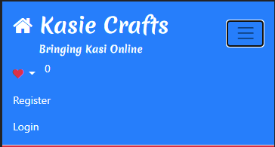

1. The following will screen option will open:

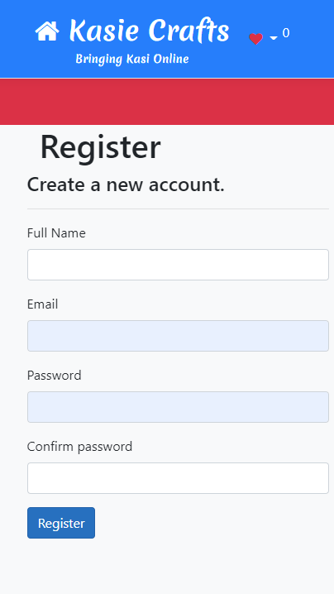

1. Full Name: Type your name and surname or the name only if that is fine with you.
2. Email: This your email address. This is the example: [myEmailAddress@something.com](mailto:myEmailAddress@something.com)
3. The password is the password you gonna use to logon each time you wanna access your account.
4. Confirm pasword: this is making sure that you didn’t make any mistakes while typing your password. Confirm password and password must match 100%. This includes matching the capital letters used and any special charactors.

**NB**: Check your email after registering. A confirmation will be sent to the email you used to register. If you don’t see any email, also check your spam or junk emails. In some email services, the email is automatically added to Junk email. Once you got the email, then follow the link in the email. This will confirm that the account is trully yours and activate it.

# Logon to the website

Why?

To access all the features of the websites, which includes, mails, new products, and managing your account.

To logon follow this steps:

1. Open the website: [www.kasicrafts.co.za](http://www.kasicrafts.co.za)
2. If the menu is visible, then click on “Logon” to logon
3. If the menu is now showing, then click the button with 3 lines as shown belown.
4. Click the “logon” menu.
5. The following screen will show-up:

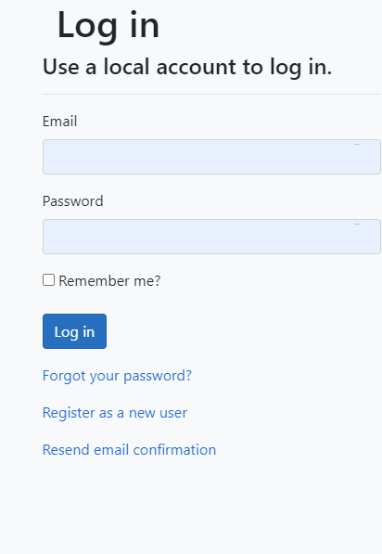

1. Email: This is your email address, the one you used on registration.
2. Password: This is the password you created, when registering.

# How to create a business account

Why?

A Business account allows you to add your business details, like your Business/Spaza name, contact details like email and phone numbers. Once the business account is created. It then allows you to add all the products or services that your business provides. Before you can add products or services you need to add a business. Then the products or service that you provide will then belong to that business. You business need

To create a business account these are the requirements

1. You need to be registered to the website. See “How to register” at the top.

To add the business account follow these steps:

1. Make sure you are registered
2. Logon to your account.
3. Then access the menu at the top. On mobile, click this button 
4. Then click “My Account”. A list of options will be availabe.
5. Choose the option “Manage Business”.
6. The screen with the green button with text “Add Business” will display.
7. If you are new, only the the button will be displayed. However if you have added a business before, then that business will be displayed on screen.
8. Click “Add Business” and add basic details (Name of your business, Description and your business house) about your business.
9. Click “Create”

# Address Details

Due to some people running their business in multiple locations and having multiple contact details, we have made provision to allow you to add multiple addresses for your business. You can have 1 to many addresses, the site will work fine.

To Add the Address:

1. Logon to your account
2. Access “My Account” (see step 3 and 4)
3. Choose “Manage Business”.
4. Next to you business name, click the “Details” button.
5. A screen will display with a button option to add Address Details . Click that button, and then create or edit your details.

# Adding Products to your Business

Once you have added your Business name, the system then allows you to add products or services that you provide. Your products could any anything, as long as it’s legal and within the current business values. To add the products follow these steps:

1. Logon to you account
2. On the Menu, access “My Account” menu item.
3. Select “Manage Business”. This will open the screen with your Business name in it.
4. Click the button “Products”. This will open a screen with all your products, and a green button at the top. That button is for adding products/ Services.
5. Click the button “Add Products”, this will allow you to add your products or Services. Please note :
   1. that at this stage, you won’t be able to add pictures of the products you are adding. Its only details about the product. You will be able to add pictures after the product has been loaded. Add products first, then the option will be available.
   2. Products or Service delivered? This options confirms if you already have a delivery method to deliver the product.
   3. Hide product from Public. This is the product that you sell, but you currently unable to provide. This option allows you to hide it from the public, until you ready to provide it again.
6. All the other information about your product or service (Product name and description)
7. Click “Save” and your product will show up on the product list.

# Adding Product Pictures

To Add pictures you have to follow this steps:

* 1. Logon to you account
  2. Access “My Accounts”
  3. Select “Manage Business”
  4. Select “Products”. A page will all the products that you have loaded will open. On each product, you will see this options (see the sample below) : 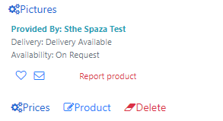
  5. These are all options for the products
     1. Pictures: This will allow you to add pictures for your product or services. A maximum of 5 pictures is allowed for each product.
     2. Prices: This is the price of the product. If the is a standard price and a pre-order prices, you use this option.
     3. Product: allows you to edit the product you have added.
     4. Delete: allows you to delete this product.
     5. Always make sure you read the headers, as some screens look identical.

# Managing Communications (Messages)

Communication is the main way most potential customers will be communicating their interests and other requirement. It is a very important component of this website. As such a screen dedicated to messages has been created, with a view that the will be future updates and improved functionality. When a person is registered, messages become a reality and a bliss to work with, since they can be linked to an authenticated user.

When a user clicks on an envelope icon, an popup window will be prompt him/her for their email address and message. The purpose is for the reciepient to be able to reply to that message. If the person is not registered, there is no way of authenticating them and confirm they are the senders of the initial message. Those registered can access the messages sent to them by following these steps:

1. Logon to you account
2. Access “My Accounts”
3. Select “Enquiries”. This will open a screen with all the message and enquiries that potential customers have sent you. The majority of these, will be sent to your email address that you used as primary email address when adding address/contact details.